Thredbo Waste and Recycling Removal – Gunyang JULY 2026
Please note the following requirements for Waste and Recycling at Gunyang:
This is the Gunyang bin enclosure:
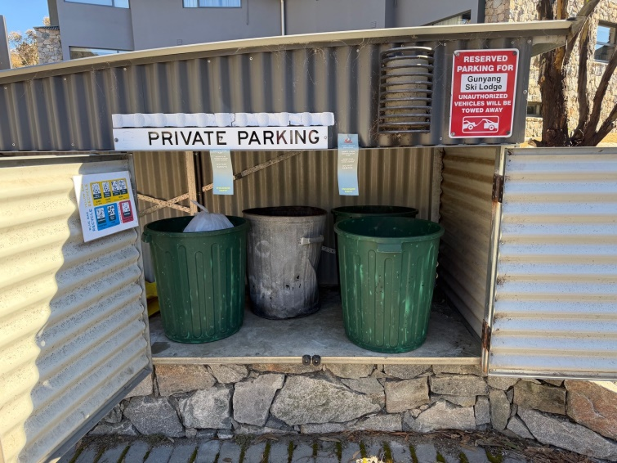
The bins on the right are for general waste only.
General Waste:
● All general waste must be securely placed in plastic waste bags.
( plastic garbage bags are above the bins in the kitchen)
● Each bag must weigh no more than 10 kg.
● Loose waste placed in the waste enclosure will not be collected.
Recycling
Recycling is on the left side of the enclosure. Only recycling bags permitted in side.
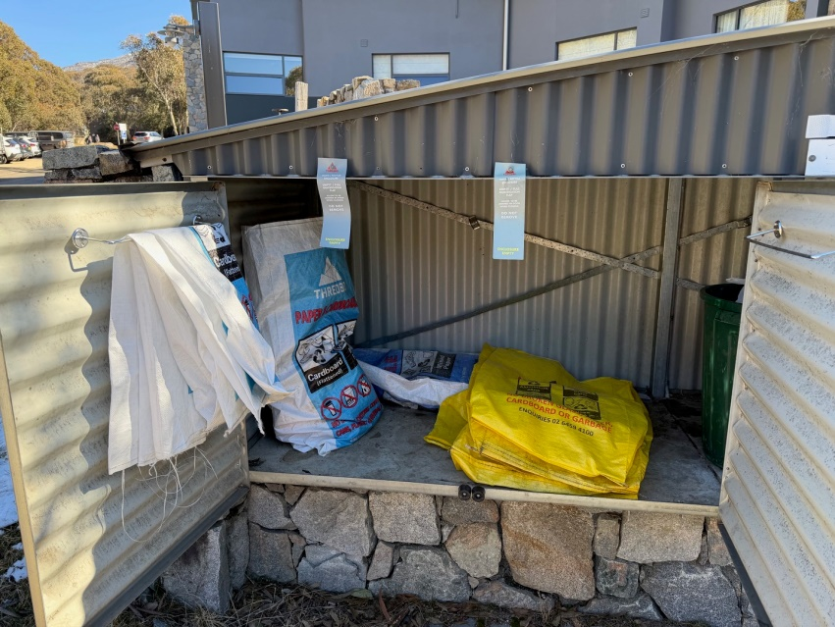
**Please do not but bottle in a box - Everything has to go in the bags.
● Yellow Bag: Glass Bottles & Jars, Plastic Bottles, Aluminium Cans, Steel Cans.
(Please do not put a plastic bag inside the recycle bags) .
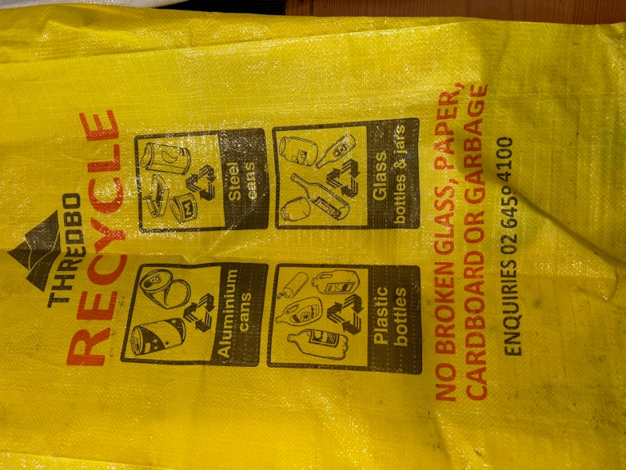
● Blue Bag: Flattened Cardboard, Paper/Newspaper & Magazine
