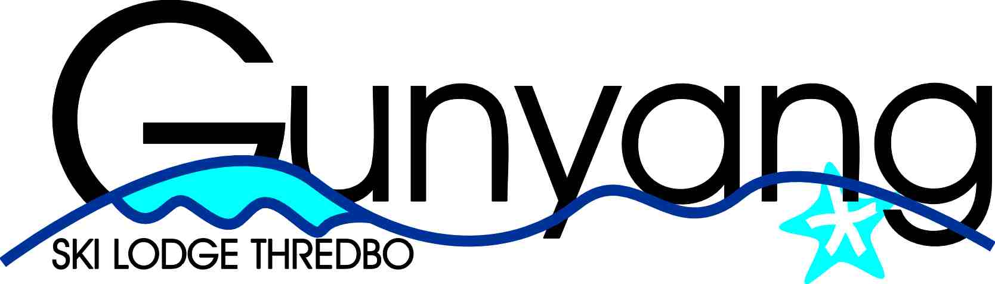
GUNYANG SKI LODGE LIMITED
ACN 110 585 656 E: bookings@gunyang.com.au

31 January 2026

Dear Members,

Letter to Members – Cleaning Cost Changes and 2026 Booking Arrangements

We are writing to inform you of the priority booking period for members relating to the winter 2026 season, an update to cleaning costs for the lodge and how these changes will be reflected in accommodation rates for the upcoming winter season.

Increase in Cleaning Costs
Our long standing cleaning provider has ceased operating, requiring the appointment of a new contractor. As a result, the cost of cleaning the lodge has increased by more than 30%.

Cleaning is a fixed cost per stay, regardless of the time of year, length of stay, or level of occupancy. To ensure the ongoing quality, safety and presentation of the lodge, and to continue operating on a sustainable basis, it is necessary to pass this increased cost through to members as part of the daily accommodation rate.

Impact on Accommodation Rates
Because cleaning is a fixed fee, the overall impact on accommodation rates varies depending on the length and timing of a booking:
- A smaller increase for longer peak season stays (e.g. 7 night bookings), and
- A larger increase for shorter non peak stays (e.g. weekend bookings).

The revised accommodation rates for the winter 2026 season are set out below.

 | Rate per room per night (incl cleaning and GST)
 |  |  | 2 nights |  | 5 nights | 7 nights
Off Peak |  |  | $367 |  | $234 | $229
Peak |  |  | $485 |  | $303 | $313
Shoulder |  |  | $421 |  | $277 | $276

Member Only Booking Period
The online booking system will open for member only bookings from 6.00pm on Wednesday, 25 February 2026.

Please note that only members who have paid their annual subscription fee of $493 prior to 25 February 2026 will be eligible to make bookings during the member only period.

There will be a three week member only booking window, during which members may book the following stay options, subject to availability:

- 2 nights – Friday and Saturday
- 5 nights – Sunday to Thursday
- 7 nights – either:
  - Sunday to Saturday, or
  - Friday to Thursday

Members may book up to two rooms at the member rate during this period. Any additional rooms for the same period will be at Non Member rates.

Public Bookings
Following the conclusion of the member only booking period, any remaining availability will be opened to the public at non member rates, which are double the applicable member rates.

We appreciate your understanding and continued support. These changes ensure the lodge remains well maintained and available for members to enjoy for many seasons to come. If you have any questions, please contact Lisa Reeve by email on bookings@gunyang.com.au.

Yours sincerely,

John Quinn
Chairman

